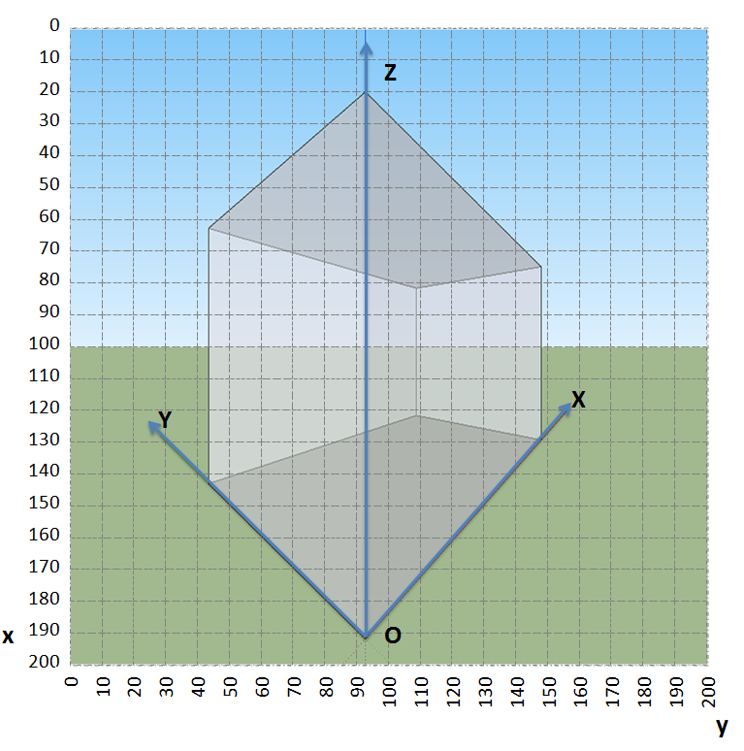**IMPORTANT: Please write your responses only within the designated area. Responses outside the designated area may not be graded.**

Question - 4

1. [10 Marks]

Consider the image of a cuboid object shown above. The image is of 200 x 200 pixels. The world X, Y, and *Z* axes are fixed to the three edges of the cuboid as shown.

What can you tell about the camera projection matrix P? Specify as much information about the camera projection matrix as possible.

|  |
| --- |
| The vanishing point in the X-axis direction is roughly at [100, 170]T as seen in the figure. Therefore the first column of P is a scalar multiple of [100, 170, 1]T  The vanishing point in the Y-axis direction is at [100, 0]T. Therefore the second column of P is a scalar multiple of [100, 0, 1]T  The vanishing point in the Z-axis direction is at [1, 0, 0]T. Therefore the third column of P is a scalar multiple of [1, 0, 0]T  The origin of 3-space is projected at [190, 92]T, so the fourth column of P is a scalar multiple of [190, 92, 1]T |

1. [5 Marks] What information *cannot* be specified about the camera projection matrix P?

Each column is known up to a scale factor. The relative scale factors of these columns are not known.

1. [10 Marks] Consider a camera having the following camera calibration matrix. Answer the following questions about this camera.



* 1. [2 points] The camera is in the canonical view. ☐ TRUE ☑ FALSE
  2. [2 points] The coordinates of the principal point are ____(1500, 2000)T_____________
  3. [3 points] What is the angle between the optical axis of the camera and the world XY plane? Explain

Since principal ray is along [0, 0, 1]T direction, thus the optical axis is aligned with the Z-axis. Hence is it orthogonal to the XY plane.